

**AMERICAN INTERNATIONAL UNIVERSITY–BANGLADESH (AIUB)**

**FACULTY OF SCIENCE & TECHNOLOGY**

**DEPARTMENT OF CSE**

**COMPUTER GRAPHICS**

**Summer 2020-2021**

**Section: J, Group: A**

**Project Report On**

**Racing Car Game**

**Submitted To**

**Dipta Justin Gomes**

**Submitted By**

|  |  |  |
| --- | --- | --- |
| **Name** | **ID** | **Contribution** |
| **1. Md. Rifat Rayhan** | **14-27736-3** | **Making all the structures** |
| **2. Muhammad Shahriar Zaman** | **20-41840-1** | **Setting up the animation and gameplay** |
| **3.** |  |  |
| **4.** |  |  |
| **5.** |  |  |

Date of Submission: **19th August, 2021**

1. **Introduction:**

We have made a top-down racing car game using OpenGL on C++. Here the player has to control a 2D car by successfully evading other cars on the road and thus score points. Though simple-looking, our project has no error or issues and emulates a basic game properly.

1. **Problem Statement:**

Throughout this course we’ve learned to draw various objects using basic shapes and also how to animate them. We’ve used such ideas to create the roads, dividers, cars, markings and roadside homes. Creating a technique to score was initially challenging, but we improvised and made a simple yet effective scoring rubric.

1. **Objective:**

The main objective of our project is to create a fun racing game which could be worked on in the future and improved. But even at this early stage we believe it to be a proper game which is engaging as well as challenging.

1. **Description of our game:**

On opening the player will first view the game homepage which will have the game title, instructions and high score. On pressing the space-bar the gameplay starts.

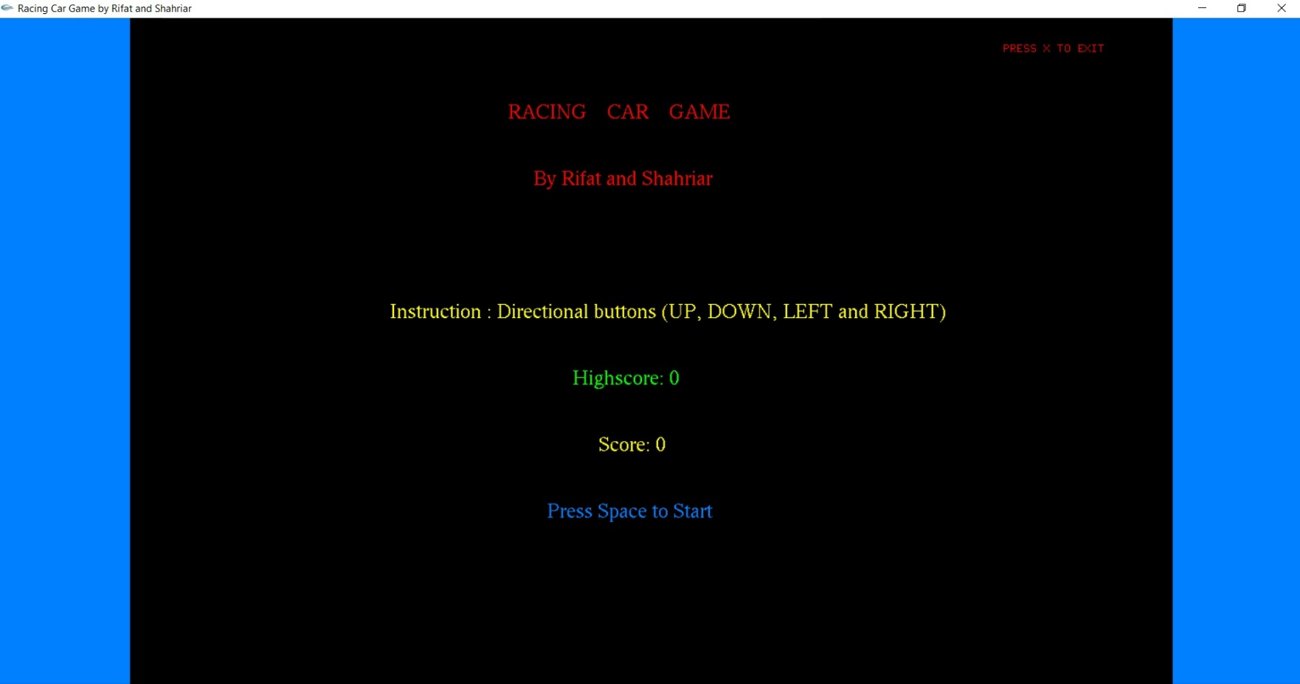

**Fig.: Home page**

**(P.T.O)**

As the gameplay starts the player can see the following. The player has to control the green car and evade the incoming red cars. The entire environment also has road dividers, markers and homes on both sides of the road.

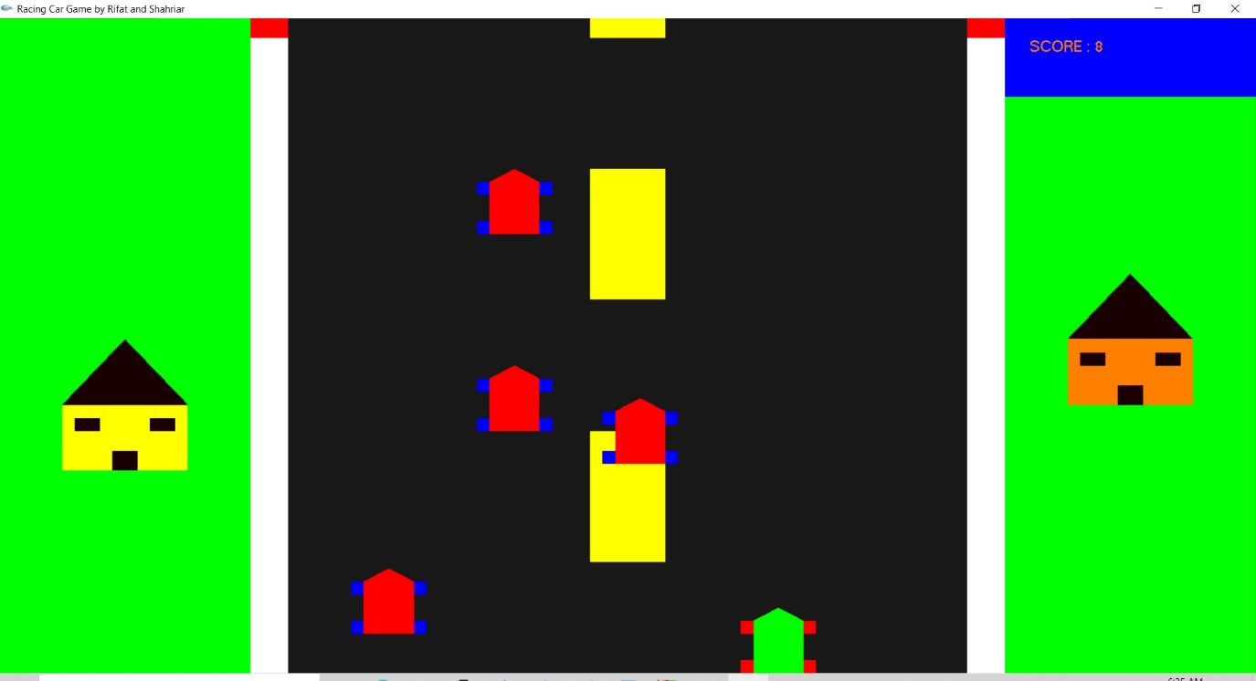

**Fig.: Gameplay**

The player can evade the cars by pressing the LEFT and RIGHT directional buttons. Pressing the UP and Dows buttons will respectively increase and decrease the speed of the car.

As the time progresses the dividers will pass through the lower periphery of the game window and a point will be registered. This way the points will keep on increasing an will be visible in the top right.

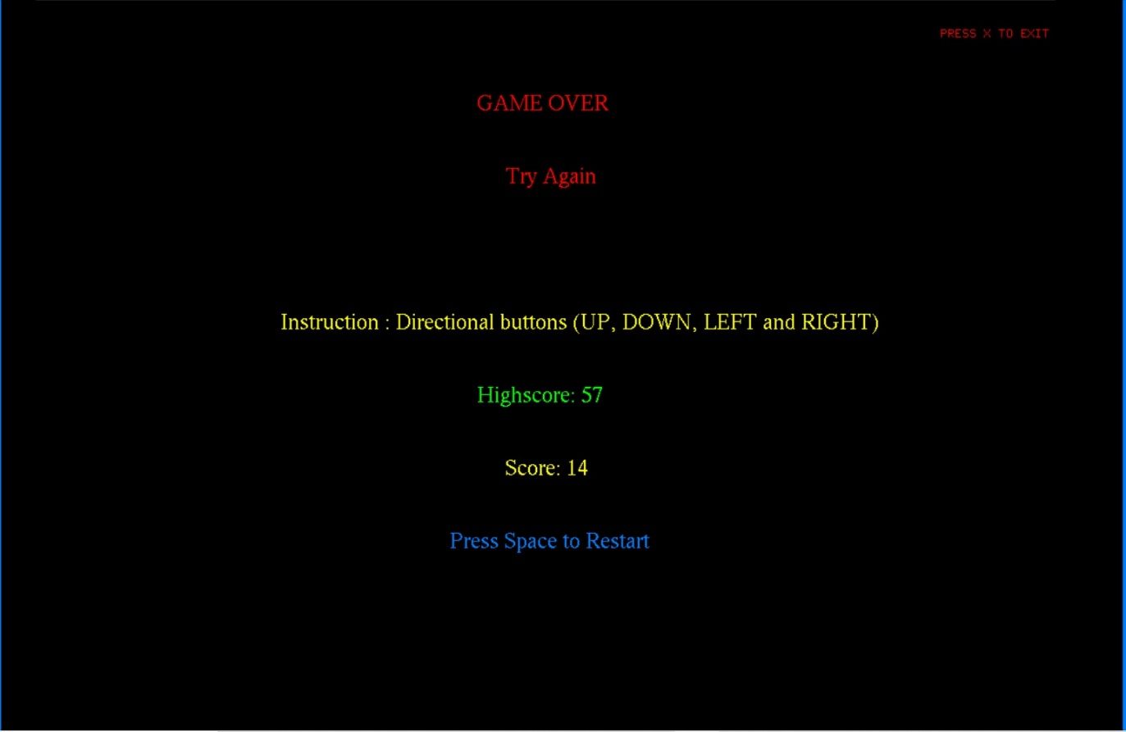If the green car crashes into any of the red cars the game immediately becomes over and an appropriate message is shown with the option to restart. We have also made a high score system which is read and stored into a text file.

**Fig.: Game-over Screen**

**(P.T.O)**

1. **Technologies used in our project:**

Here we have used basic shapes to form the various structures in our games. Triangles and rectangles were used to make the homes, polygons and squares were used to make the cars and rectangles were used to create the road dividers.

We have used principles of translation to set our structures on motion. All the cars, homes and dividers have variable coordinates which gradually change in the Y axis and X axis respectively according to the need of the game.

1. **Library functions used:**

int main(int argc, char** argv);

glutInit(&argc, argv);

glutInitWindowSize(1100,650);

glutInitWindowPosition(200,20);

glutCreateWindow("Racing Car Game by Rifat and Shahriar");

glutDisplayFunc(display);

glutSpecialFunc(movement);

glutKeyboardFunc(primaryCommands);

glutTimerFunc(1000,timer,0);

glOrtho(0,100,0,100,-1,1);

glClearColor(0, 255, 0,1);

glutMainLoop();

glFlush();

glutSwapBuffers();

glClear(GL_COLOR_BUFFER_BIT);

glColor3f(1.0f, 0.5f, 0.0f);

glBegin(GL_POLYGON);

glVertex2i(80,100);

glVertex2f(25+ xAxisMainCar,yAxisMainCar+2);

1. **Created Functions:**

void movement(int key, int x, int y);

void homePage();

void renderBitmapString(float x, float y, void *font,const char *string);

void playGame();

void display();

void timer(int);

void primaryCommands(unsigned char key, int x, int y)

1. **Conclusion:**

We made this game with the goal of making something simple yet fun. We have also made sure that it works almost perfectly and has no issues or bugs. All the issues faced during developing the game were solved by us. We hope our efforts will be fruitful.

**You can download our project from the following link**

**https://drive.google.com/drive/u/0/folders/1qUMSWecySTS7jfvA4sAHK4PyFKJsqpqG**